# LADM in the Classroom

# – Making the Land Administration Domain Model Accessible

**Christiaan LEMMEN, Andre da SILVA MANO** **and Malumbo CHIPOFYA, Netherlands**

**Key words**: Curricula, Education, Educational Datasets, Open Courseware, Land Administration, Standards, LADM, Land Administration Domain Model

SUMMARY

At Faculty ITC, we have noticed that it can be challenging for students to fully understand the Land Administration Domain Model (LADM). Given the complexity of the subject, this can be expected. Good teaching aids that materialise the concepts and diagrams prescribed in the standard are needed. Part of the problem is that the modelling language, that is the 'Unified Modelling Language', is not so easy to understand. Whoever wants to understand LADM must also understand UML.

We developed a new approach. Offered datasets modelled according to the LADM standard open up the possibility of teaching from the concrete level (end product) and not from the abstraction level in UML (Unified Modelling Language). This means starting from a cadastral map with visually linked rights and entitled parties. Then the translation of this data into database tables is the next level of understanding. What do these tables look like for the data shown on the map? Finally, the link between database tables and UML diagrams is presented to the students.

A virtually accessible LADM implementation that starts with the concrete and ends with the abstract is better understood by students than the UML model of the LADM. This is a good support in the learning process.

Different scenarios can be derived from a single dataset, demonstrating multiple levels of complexity and model variations that accommodate different local land tenure arrangements. The presentation in this session will consist of an introduction showing the different steps (i.e. map, tables, UML model). Afterwards, a live demonstration will show the didactic possibilities that such a dataset, and the associated tools, can offer.

All introduced tools will be published under an open, permissible license to invite all actors in the community to use them.

# LADM in the Classroom

# – Making the Land Administration Domain Model Accessible

**Christiaan LEMMEN, Andre da SILVA MANO** **and Malumbo CHIPOFYA, Netherlands**

1. INTRODUCTION

The Land Administration Domain Model (LADM) offers a comprehensive functionality in support to documentation of the relationships between people and land in a land administration (ISO/TC211, 2012; Lemmen et al., 2015). Within the professional land administration world, the model is known and used in the development of land administration systems. Kalogianni et al. (2021) present forty country profiles and ten national implementations of the LADM. With the Social Tenure Domain Model (STDM) (Lemmen, 2010), there are many more. Quite a lot ten years after the introduction of the standard.

There is a user community that meets regularly and exchanges experiences during LADM Workshops, see for example Kara, et al. (2022) and the TU Delft wiki at the end of this paper. The tenth workshop was recently held in Dubrovnik, Croatia. A solid scientific foundation for the LADM is established in many scientific publications, see the wiki. Software suppliers are building applications. All this demonstrates that the functionality offered by the model is useful.

At Faculty ITC, University of Twente, The Netherlands, we have extensive experience in teaching land information modelling with the LADM. Through this experience we have observed that fully understanding the LADM can be challenging for students and novices. Given the complexity of the subject, this can be expected. Good teaching aids that materialise the concepts and diagrams prescribed in the standard are needed. Part of the problem is that the modelling language, that is the 'Unified Modelling Language', is not so easy to understand. Whoever wants to understand LADM must also understand UML. This is needed to see, analyse, interpret, apply and thus understand the wealth of functionality the LADM offers.

We developed a new approach. Offered datasets modelled according to the LADM standard open up the possibility of teaching from the concrete level (end product) and not from the abstraction level (UML). This means starting from a cadastral map with visually linked rights and entitled parties. Then the translation of this data into database tables is the next level of understanding. What do these tables look like for the data shown on the map? Finally, the link between database tables and UML diagrams is presented to the students. This approach is presented here.

The different levels of abstraction that can be addressed allow the student to attain several levels of learning when considering the revised Bloom's Taxonomy proposed by LW et al. (2001). Depending on the learning outcomes, the types of knowledge that can be explored include *factual knowledge*, *conceptual knowledge*, and *procedural knowledge* used within learning levels ranging from *understanding* to *evaluation –* covering five of the six levels of learning.

Along with the didactic approach, we made an effort to ensure the datasets have a low entry barrier regarding financial costs and software availability. All the datasets are distributed using open specifications, and the exercises assume the use of QGIS and PostgreSQL/Postgis. These are well known open software projects that are available, maintained, reliable and safe - attributes of software sustainability as defined by Venters et al. (2014). The sustainable element is vital to ensure the educational materials we now present will remain relevant and usable in the foreseeable future. On top of open specifications, the datasets and accompanying resources are published under a permissive Creative Commons *Attribution-Non Commercial 4.0 International License.*

This paper starts from a cadastral map with visually linked rights and entitled parties in section 2. Then individual cases are shown in so-called "instance level diagrams" section 3. The translation of this data follows this into database tables – the next level of understanding – introduced in section 4.. Then a virtual accessible environment is introduced in section 5 and the development of exercises in section 6. Finally, local land tenure arrangements (in a customary area) are presented in section 7. There is a short conclusion in section 8.

1. PEOPLE TO LAND RELATIONSHIPS AND THE CADASTRAL MAP

In teaching land administration at the ITC, we try to establish methodologies for documenting formal  people land relations as well as informal ones, such as areas with traditional customary tenure or slum settlements. People to land relationships are complex, as are people to people and land to land relationships. See Figure 1.

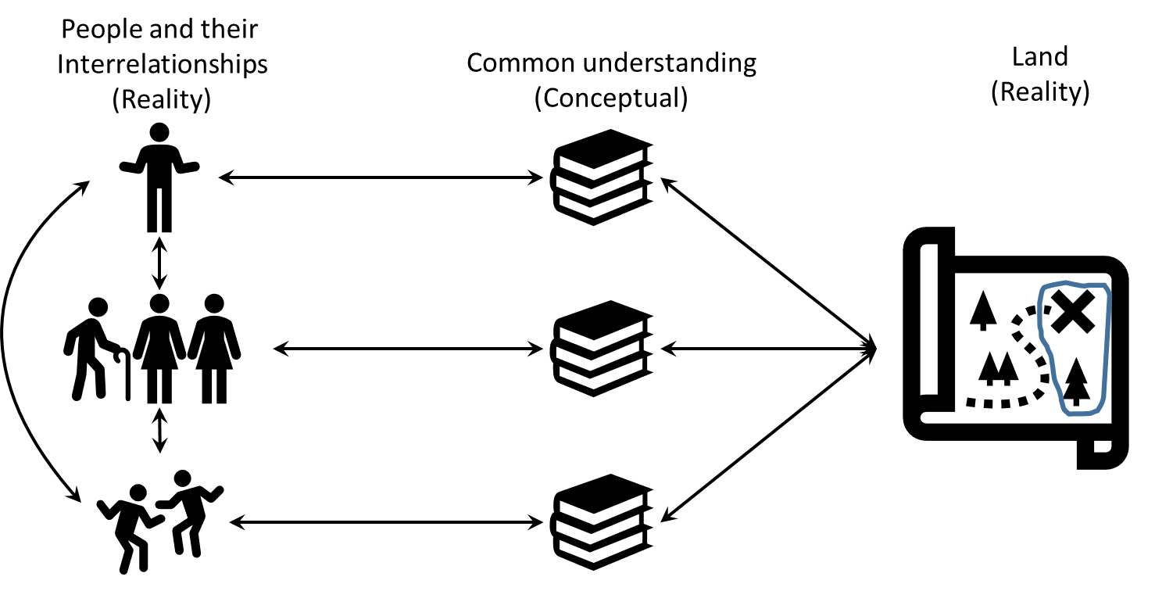

Figure 1. People-land relationships and the cadastral map as representation of reality

People to people relationship can be about natural and non-natural parties (or persons), about families, about polygamic relationships. People can be included in a land administration or in a connected population register. For the people to land relations, the continuum of land rights should be applicable (UN-Habitat, 2008). For representation of the boundaries, besides the traditional fixed and general boundaries, also fuzzy and dynamic boundaries must be possible to be included in the land administration. The same goes for overlapping spatial units and overlapping tenure systems. Disputes must be depictable.

The students at ITC are educated in UML of course. During the Covid period, we suddenly realised that in addition to our slides with many LADM UML models, we were frequently using the white board in the class room to illustrate people to land relationships. The students always diligently copied this. However for the remote classes there was no comparable replacement for the white board and marker. At the beginning of the Covid lockdowns, in the absence of functional white board, we found ourselves unable to effectively communicate and demonstrate the different LADM concepts to our students. It never occurred to us that the reason being that we could no longer make use of representations of the cadastral reality (and its corresponding database tables) on the whiteboard interchangeably with the LADM and its UML diagrams projected on a screen. See Figure 2 for a whiteboard example case.

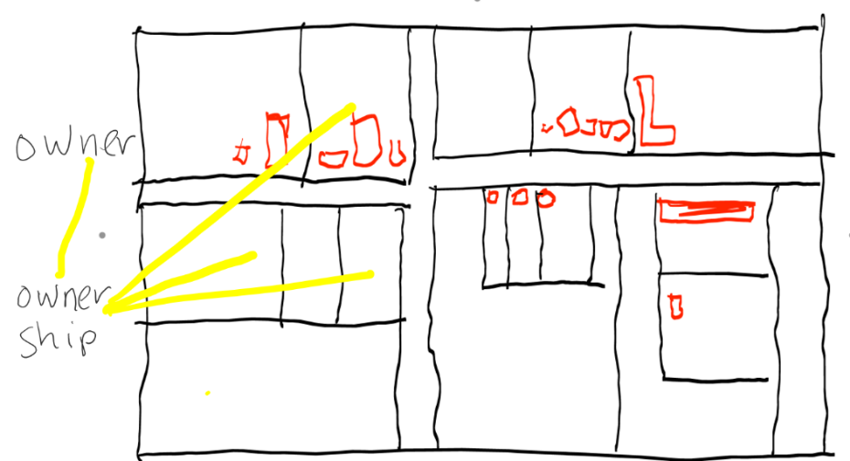

Figure 2. Use of the whiteboard to show people to land relations

On our LADM lecture slides we showed UML class diagrams with several types of associations (relations between classes) and multiplicities included. Multiplicities indicate the number of instances of one class linked to instances of another class. For example, a party (right holder) will have one or more land rights. Those slides with class diagrams were further combined with slides with the LADM attributes – with formal definitions to explain their semantics. Colleagues at Kadaster Netherlands had said softly that the LADM is nice and important – but that presentations became boring as soon as the UML diagrams appeared. For the connoisseurs, that was where the fun started, but the others dropped out. Even when they were aware that LADM is about the essence of Land Administration the land data. Problem is that they simply did not understand how to read the UML diagrams. We did not pay enough attention to these kinds of critique.

The solution is as simple as it is effective: all those endless numbers of drawings on the whiteboard of cadastral maps showing people to land relations had to be included in the slides. And in the videos explaining the slides. That makes the introduction of LADM applicable in remote learning and in Massive Open Online Courses (MOOCs) if required. Please notice that this type of learning also happens within projects and consultancies. We have worked out the visualisation of the formal legal situation using a of total 15 parties, 17 rights, 13 basic administrative units and 22 spatial units. Something similar was done for a customary area, see further on in this paper.

Figure 3 shows the starting point: the cadastral map. The map shows Thomas and Elisabeth having a right of ownership on spatial units WR02, WR03 and WR04 in the village of Water River.

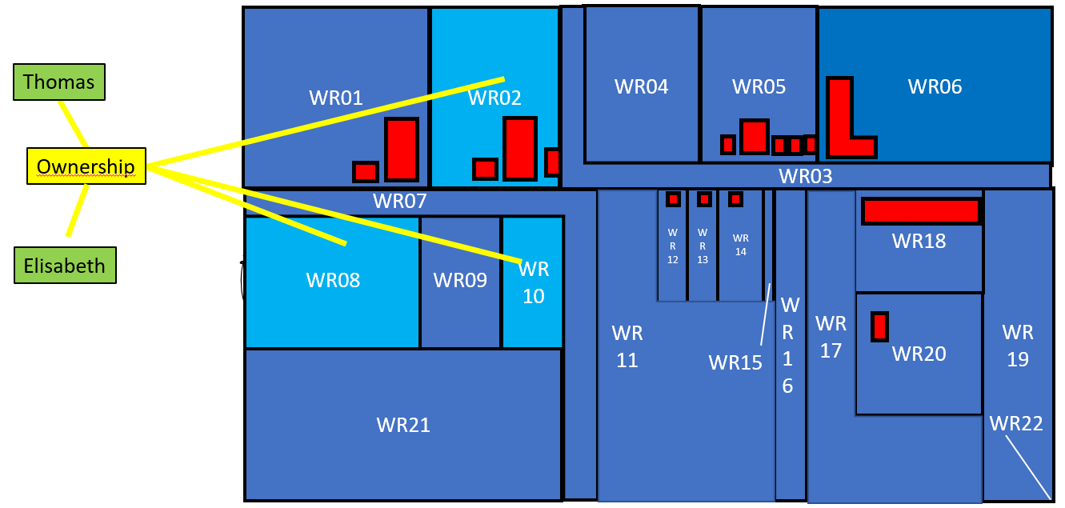

Figure 3. Elisabeth and Thomas have a right of ownership on the spatial units WR02, WR08 and WR10 in Water River

Figure 4 shows a 3D map of property units "owned" by Monique. She holds an apartment – with a parking space and laundry room.

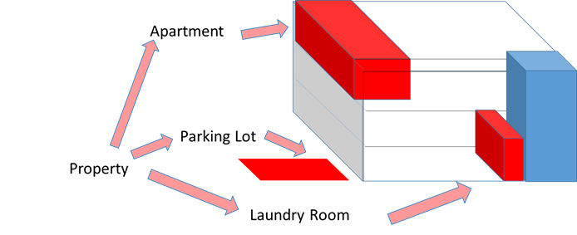

Figure 4. Monique owns an apartment (WR18-4) with parking lot (WR18-5) and laundry room (WR18-6)

The visualisations presented in the material are based on a single dataset prepared specifically for this purpose. The dataset consists of a map created in a GIS, with data about people-to-land relations realising different scenarios. Figure 5 shows the map of the "case study" area.

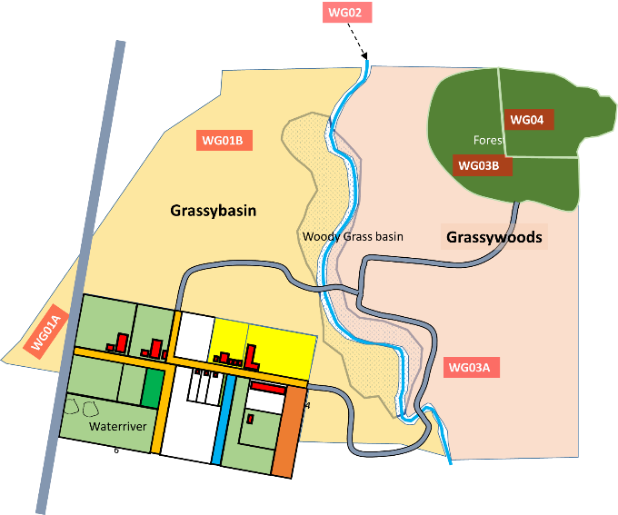

Figure 5. Map of hypothetical region comprising the LADM learning and teaching dataset.

The area includes an urban settlement called *Waterriver* surrounded by a rural area consisting of two distinct communities, *Grassybasin* and *Grassywoods*, each with its own social governance structures. As we will see later on, our dataset allows us to present a wide variety of land information modelling scenarios.

1. INSTANCE LEVEL DIAGRAMS AND DATABASE TABLES

Then, in group discussions, we discuss how Thomas and Monique's situation can be depicted with the LADM. In the LADM the administrative/legal data, the 'registry' and the spatial data, the 'cadastre', are represented in one integrated model. A good way to introduce the structure of this model is to start with concrete depictions of how the records relate. Taking the case of Monique, Figure 6 presents a reader friendly schematic showing which objects are involved and how they relate to each other. This directly translates to the more UML-like instance diagram in Figure 10.

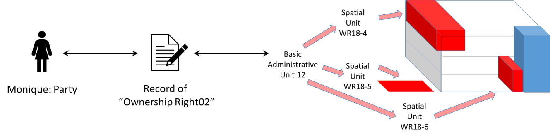

Figure 6. Monique has a single ownership right to three property units in the apartment complex – the apartment (WR18-4), the parking lot (WR18-5) and the laundry room (WR18-6) . These are grouped into Basic Administrative Unit 12.

Now the question is whether Tomas and Elisabeth each have an individual right? See the rights 02 and 03 in the "instance level diagram" Figure 7. These diagrams present static snap shots of instances (not classes) in the LADM. It shows exactly what points to what.

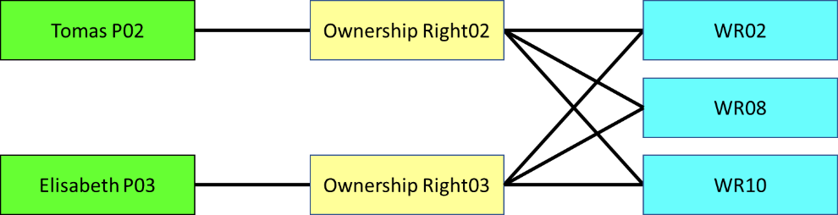

Figure 7. Thomas and Elisabeth each have a ownership right of the spatial units WR02, WR03 and WR10

Or do they have a share (e.g. 1/2 each) in a single right? See the shares in the right 02 visualised in Figure 8.

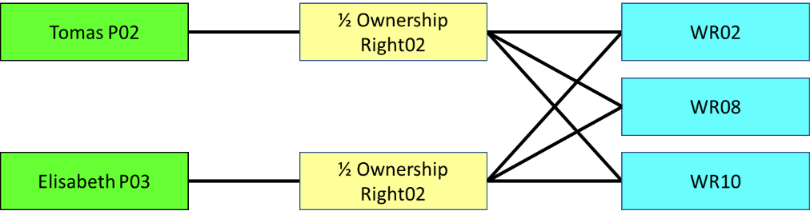

Figure 8. Thomas have a share in one ownership right in spatial units WR02, WR03 and WR10

Or is it more convenient to group the three spatial units into one basic administrative unit (property units), as illustrated in Figure 9. Here Thomas and Elisabeth have a share in one ownership right related to a Basic Administrative Unit 2 (BAU02). BAU02 is composed of three spatial units WR02, WR03 and WR10.

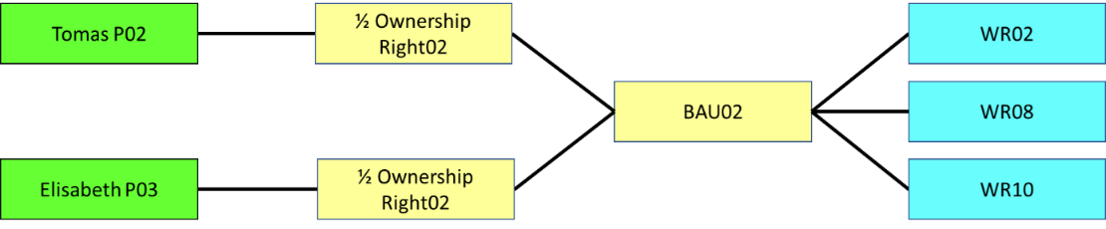

Figure 9. Thomas and Elisabeth have a share in one ownership right related to a basic administrative unit 2 (BAU02). BAU02 is composed of three spatial units WR02, WR03 and WR10

The case from Monique is presented below in Figure 10, also in the form of an instance level diagram. As said she owns the spatial units WR18-4, WR18-5 and WR18-6.

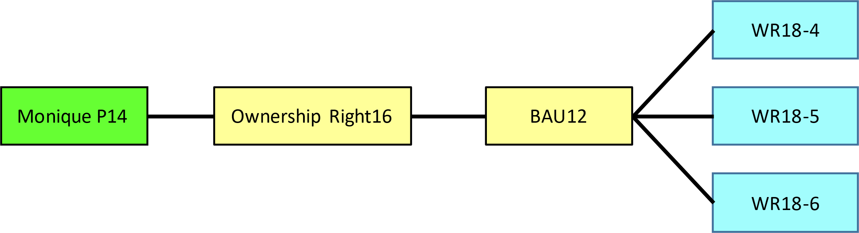

Figure 10. Monique owns basic administrative unit 12, this unit consists of the spatial units WR18-4, WR18-5 and WR18-6

The LADM functionality for basic administrative units may look overdone. This functionality was particularly useful for taxation cadastres - when sending tax assessments, overviews per right holder, per municipality (which often sends the assessments) of the values of all parcels are useful. It is also useful in situations where a set of spatial units composes a property.

With all the instance level diagrams for all cases together the database tables for the parties, RRRs, basic administrative units and spatial units can be visualised.

1. DATABASE TABLES AND UML DIAGRAMS

Now that we have the database tables available, we can explain the relationship with the classes in the class diagrams. See Figure 11, from left to right party, RRR, BAUnit and Spatial Unit.

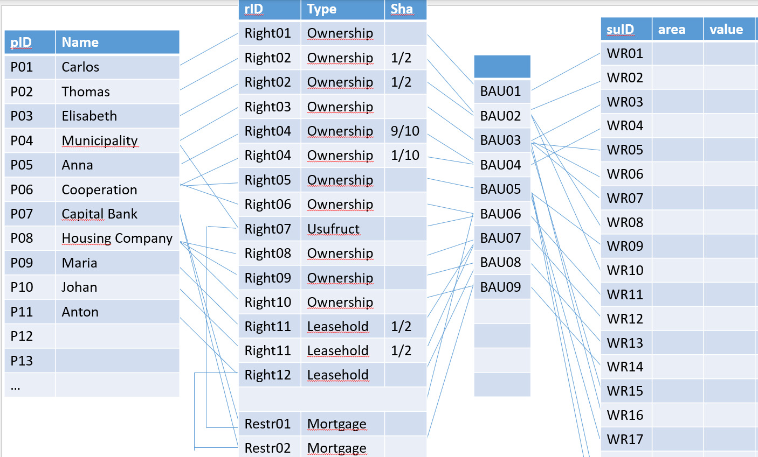

Figure 11. The database tables can be derived from the instance level diagrams

The Figure 12 below illustrates how to read the displayed class in UML. The attributes in the Party class are listed below each other in the UML class diagram. But in the database tables they are columns that are next to each other. For many colleagues without a design background in ICT this is an eye-opener. Now the whole LADM class diagram is understood a lot better - so is our experience. And also the link between the UML class diagram and the database tables.

Figure 12. The attibutes in UML are database colums

And the whole LADM class diagram is understood a lot better – in this "step by step approach", from package (see for example the LADM Party package in Figure 13) to the complete LADM. So is our experience.

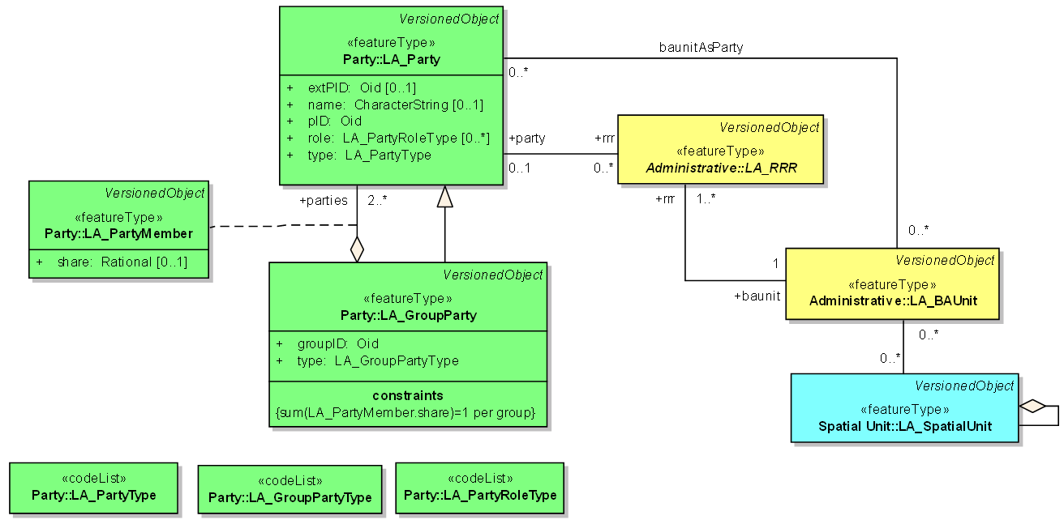

Figure 13. From Class to package, the from package to the complete LADM class diagram

We are aware that this approach is a "bottom-up" approach. But it works.

1. VIRTUALLY ACCESSIBLE LADM

A virtually accessible LADM environment has been created. See the link at the end of this paper. In this environment the datasets take two forms: geopackages (.gpkg) containing spatial and non spatial layers and, as an alternative, a PostgreSQL database dump file that can be deployed to a PostgreSQL database server with PostGIS extension enabled. In both cases, a QGIS project with pre-loaded and pre-styled datasets serves as the frontend (Figure 14).

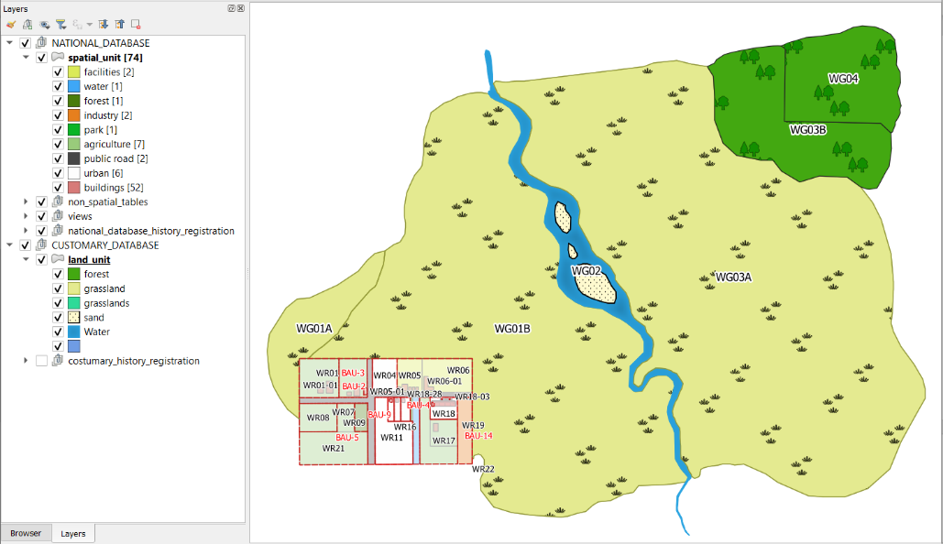

Figure 14. Datasets loaded into QGIS

The project is organised around two main groups of datasets – one documenting a formal, national dataset and another group containing the tables referring to the customary lands, see section 7.

Within each group, information on land, rights and parties can be seen along with a subgroup for history registration, where records of all the edits that the user performs over the dataset are stored. Different scenarios can be derived from a single dataset from this initial setting, demonstrating multiple levels of complexity and model variations that accommodate different local land tenure arrangements.

In its simplest form, the user can pan the map and explore the attribute tables. The exploration can also be performed via a web map application. However, the virtual environment is prepared to support data views that are used to show more complex relationships between the datasets. These take the form of new tables and layers, as the case of Basic Administrative Units BAU (Figure 15), an often confusing concept to understand.

Figure 15. Example of a data view (Basic Administrative Unit)

Of course, the actual implementation logic is also available, and as such, the SQL statement behind every view is also made available (Figure 16).

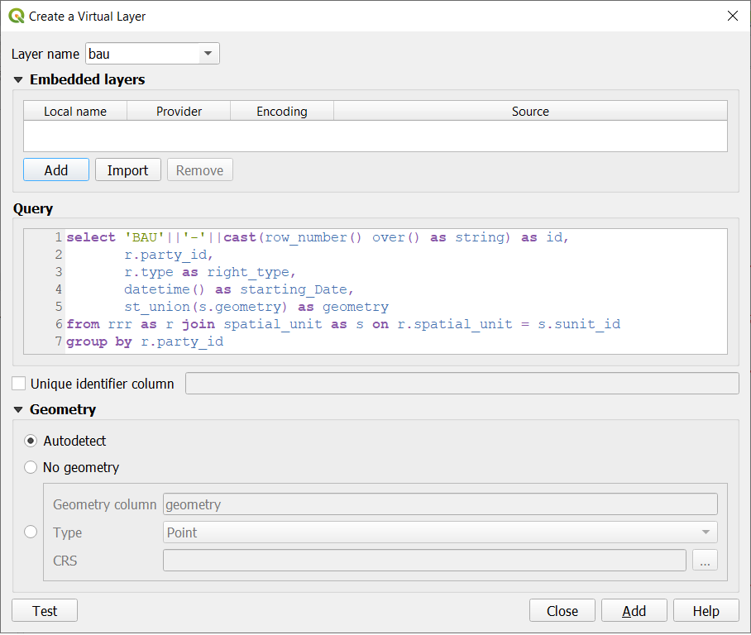

Figure 16. SQL View

This is a high level of detail that might not suit all courses, but it is essential to provide it as an extra possibility. The exploration of advanced implementation queries is similarly applied in the case of history registration.

Upon conducting any kind of transaction, the previous state of the dataset is kept in a designated table. The trigger functions behind such automatisation are also available for those interested in going deep into implementation issues.

Finally, the user has the possibility of executing transactions that alter the state of the database - examples of such exercises are provided in the next chapter. From the point of view of the virtual environment, such transactions can be done either using the Graphical Interface or purely through SQL statements, thus enabling factual, conceptual and procedural knowledge if that is the instructor's objective.

1. DEVELOPING EXERCISES WITH THE DATASET

Implementing the dataset in an actual database allows us to create exercises to form part of the learning material. Exercises can be developed objectively at several levels of the Bloom taxonomy of learning (Anderson et al., 2001). As a proof of concept, we present three levels of complexity of exercises developed using the implementation setup and dataset. The first two levels are illustrated with simple examples.

The most basic exercise addresses the base (knowledge) and second (comprehension) tiers of the Bloom cognitive model. The student is asked to draw the UML instance diagrams for a given scenario and to identify the UML class of each object in the diagram. For example:

1. Consider the following situation: "Monique has ownership rights to a plot".
   1. Draw a UML instance diagram depicting this situation in the LADM model.
   2. Indicate for each object in your diagram, which UML class it belongs to.
   3. For each object, attribute data must be collected to comply with the LADM standard – please list the attribute names for each object.
   4. For each association, indicate the association's name if it is explicitly given in the LADM standard.

This exercise assesses how the student has assimilated the core LADM classes and the idea that a class represents a group of objects of the same kind such as a party. It also shows that the student can use the core LADM classes to describe a specific scenario. The solution to problem 1.a. would look exactly like the bottom row of boxes in Figure 18 (a) or (b), except the class of each object would be included in the diagram or as a separate descriptive text. It should be noted that from this initial problem, questions related with other knowledge areas such as model representation in relational database tables, basic SQL query syntax or and spatial representations may be derived.

A student who answers all basic problems such as problem 1 correctly would be ready to tackle more challenging problems involving the application of the knowledge to several different scenarios not directly presented in the examples. This is where the concept of country profile becomes a useful teaching tool as it provides real-world land administration models. Consider the problem presented below

1. Given the initial scenario shown in Figure 17, where Monique owns an apartment, laundry room, and parking space in an apartment complex (as depicted in Figure 4),
   1. redraw the instance diagram where a single entity, Galaxy Properties, buys out the entire property. In the new scenario Galaxy Properties now owns both the land and all the structures on the residential complex.
   2. Write the SQL queries required to update the data to reflect the new scenario.

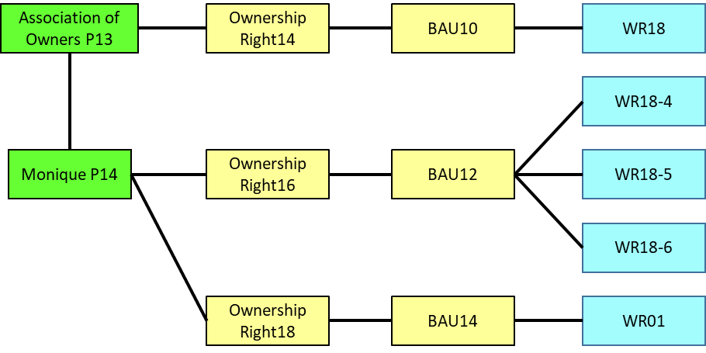

Figure 17. Scenario presented for exercise question 2

This kind of question assesses the ability of the students to apply what they have learned about the LADM to a new scenario. That includes upstream information related to BAU14 not being affected by the changes. The student must understand the way multiplicities are used in UML and be able to crosscheck the validity of their answer with respect to the LADM.

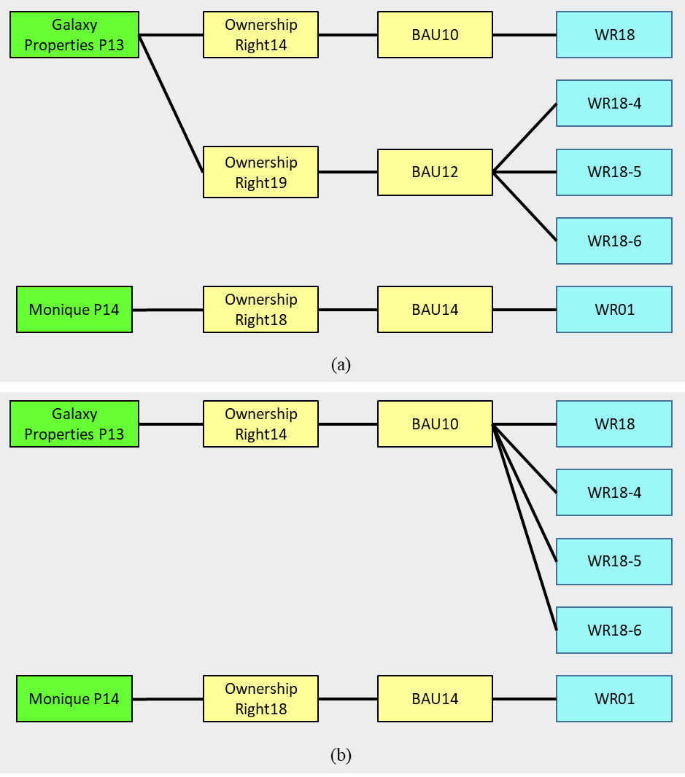

Figure 18. Possible answers for exercise 2. (a) transfer of ownership rights by shifting only the reference to the right and therefore anything that follows-on, (b) the ownership rights are transferred by moving each spatial under a Basic Administrative Unit over

Figure 18 shows the two possible solutions for problem 2.a. Both answers are admissible within LADM but either might or might not conform to a particular country profile. Problem 2.b. assumes that the student has already developed or has been provided with the corresponding database schema.

The third and most advanced level of exercises would address the 5th level competences in Bloom's hierarchy which involve the capacity to synthesise the learned knowledge and create new ideas or structures from it. An example of such a competence is when a student can model a previously unknown tenure arrangements in a way that captures their semantics as well as possible.

The section below demonstrates how local land tenure arrangements that do not follow the statutory tenure system can be modelled within the LADM. This, of course, is an advanced topic that is best dealt with after students have mastered the basics of LADM modelling.

1. LOCAL LAND TENURE ARRANGEMENTS

Modelling non-statutory land tenure arrangements requires assessing which elements of the domain can and cannot be modelled statically in UML. In cases where land rights are fluid (having degrees of existence) or dynamic (applying conditionally subject to other some other factors), such rights might have to be modelled using other UML constructs such as the Activity or State machine diagrams, especially as presented in Seidl et al. (2012), pp 85-106. Chipofya et al. (2020) also present an alternative modelling approach using semantic web languages, Web Ontology Language OWL/DL and Semantic Web Rule Language (SWRL). Their so called Local Domain Models are implemented in the customary land tenure documentation tool called SmartSkeMa (Chipofya, 2021) which provides a mechanism to translate between locally defined land concepts and LADM terms, i.e. classes.

This section presents possible modelling options for a customary land tenure domain using the Water River database. The two communities on the outskirts of Water River both follow a customary land governance regime. Under a newly enacted Community and Customary Lands Act, communities can opt for registration of community land to protect the land they depend on from dispossession by outside actors by applying for a community land title over the entirety of the land over which the community has traditionally exercised use or other rights. This affords communities and their member's security of tenure.

For community or customary lands registration, the claimants must first be registered as a legal entity or group of legal entities. In addition, it is necessary to document individual members of the community at any material moment. Using the LADM several options are possible: registration can involve composite parties with defined (all members identified separately) or non-defined membership (representative(s) is(are) identified but not all members). In the latter case individual members can be documented either in a local register or as beneficiaries of the officially registered entity.

The registration of the two communities, Grassybasin and Grassywoods, is shown in Figure 19. In Figure 19 (a) Grassybasin is registered with all 82 community members registered as part of the group party with ownership rights on the Grassybasin territory. Grassywoods is registered with only 9 representatives registered as part of the group party with ownership rights on the Grassywoods territory (Figure 19 (b)). In both cases the group party represents the interests of 119 members of the community – i.e. the community as a whole.

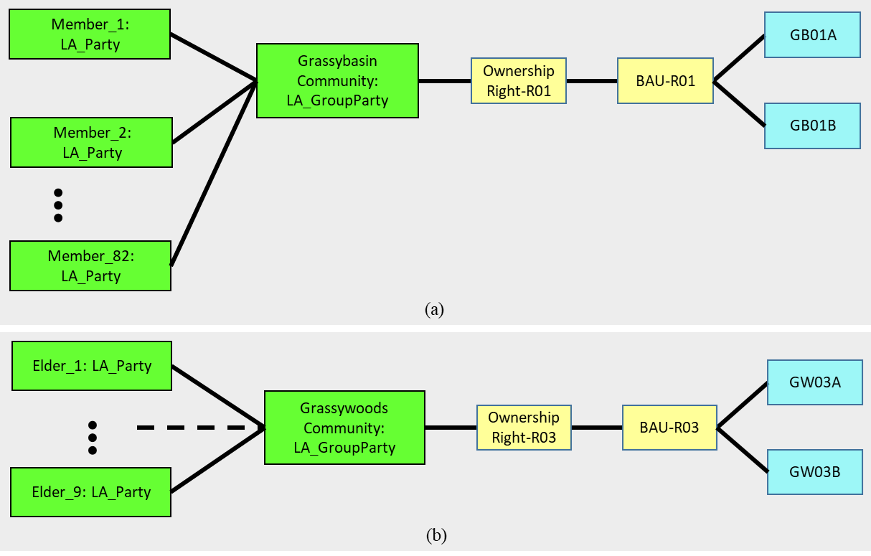

Figure 19. Registration of communities. (a) Grassybasin is registered with all 82 community members registered as part of the group party, (b) Grassywoods is registered with only 9 representatives registered as part of the group party

Figure 20 shows that the Grassywoods community, having been registered under the undefined membership model, maintains a community register updated in real time as land rights and members change.

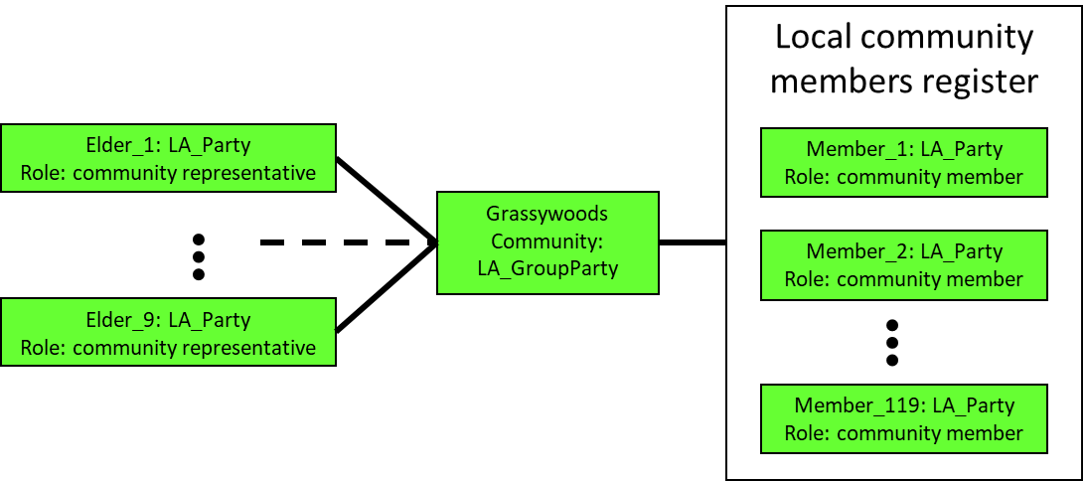

Figure 20. Instance diagram illustrating the separation of the official registration and the local register of members.

Additional complexity concerning these formal land rights can be introduced. For example, the river which forms the boundary between the two communities' lands is owned by the state as are all major natural water bodies in the country. However, the two communities have long since exercised non-exclusive rights of use on the river and its banks. These are modelled as usufructuary rights. Other usufructuary rights at the formal level included in our current examples include use rights in the forest area which is designated as a protected forest with part of it owned by the local municipality and the other part owned by the Grassywoods community.

In addition to rights, responsibilities can also be modelled for the customary land using LADM. For example, the Grassywoods community has maintenance responsibility on the protected forests area recorded as Spatial Unit WG03B. These usufructuary rights and maintenance responsibilities are all shown in Figure 21.

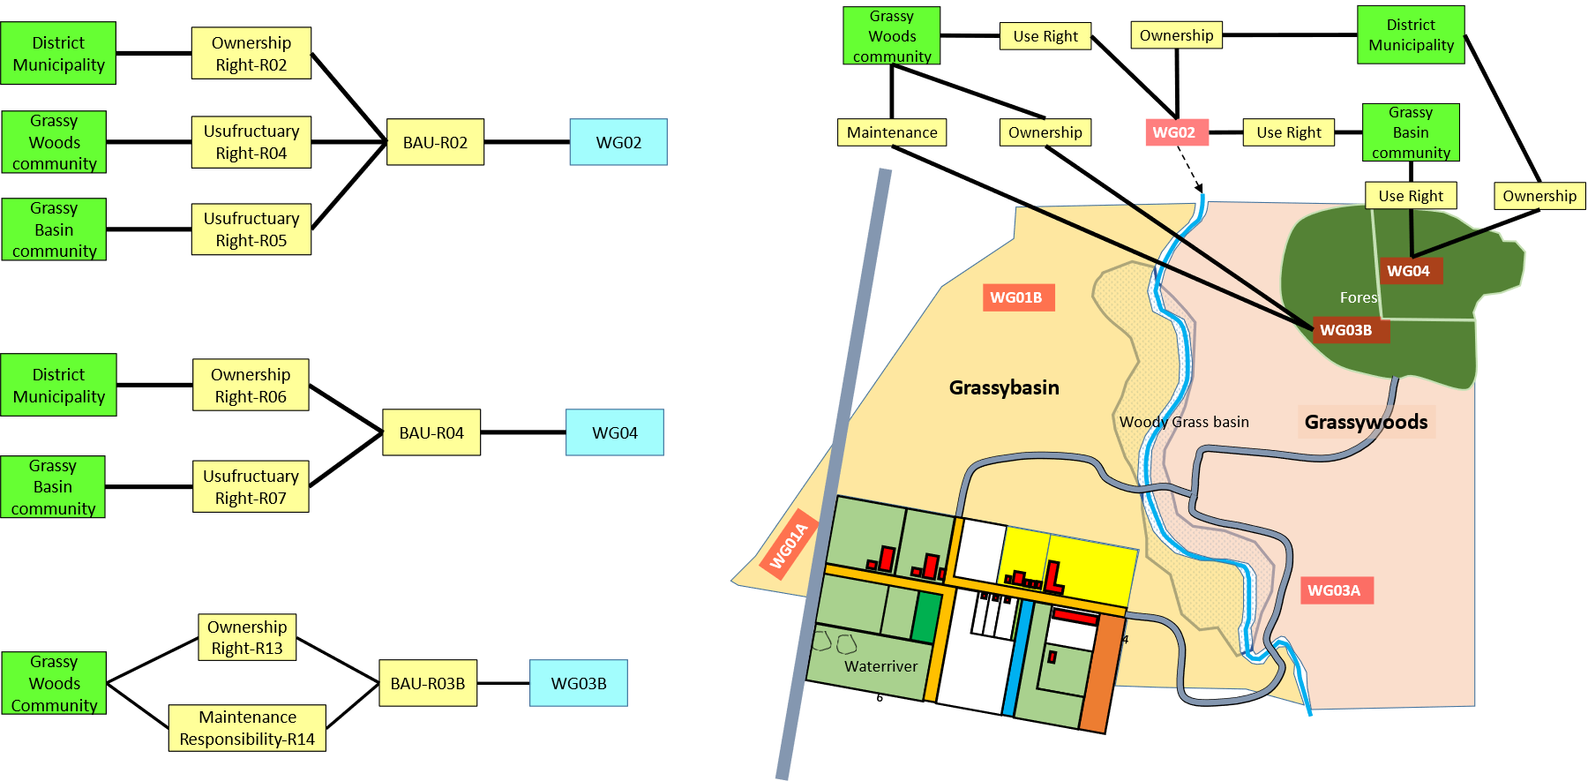

Figure 21. Visualising usufructuary land rights and responsibilities in the customary areas of Grassybasin and Grassywoods.

All is well when considering the formal registration of rights on customary territories. However, state authorities might be interested in observing the exercise of land rights within the customary system to ensure the protection of basic rights and/or livelihoods of all members of the community or other parties with land rights claims over the community lands. As a first example we consider the case of a rental (or short lease) defined within the customary system. The terms of such rental are defined within the customary norms and traditions of the communities of Grassybasin and Grassywoods. Our example, depicted in Figure 22, presents the case where a plot of land in Grassybasin originally allocated to a local resident, Mwalimu, is rented out to an outsider, Mnandi. The rental right is modelled in the normal way. However, there is an associated right that arises from the rental arrangement: the right to access the resources of the forest WG04. In Figure 22 this is modelled as a constraint on the rental right and usufructuary right – that is, the right is modelled as a personal right.

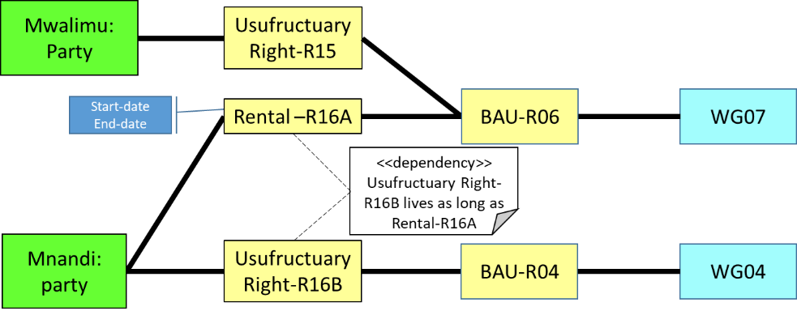

Figure 22. Modeling of personal right: access rights on forest resources deriving from rights of use on a farming plot within the community.

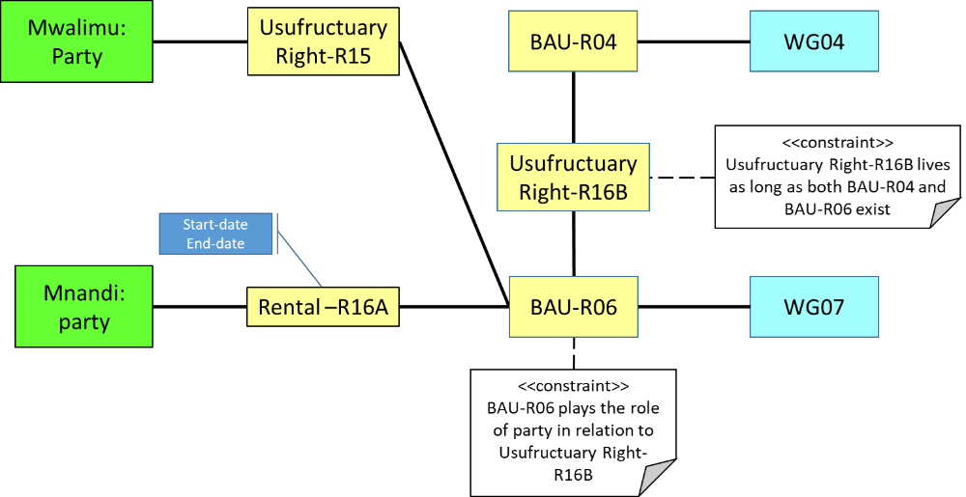

Figure 23. Modeling of property right: access rights on forest resources are permanently granted to BAU-R06 (a basic administrative unit taking on the role of a party) for as long as the farming plot exists with that designation. Users of the plot under BAU-R06 derive their right to access the forest resources from their rights on the plot.

Alternative modelling in terms of the rights on the plot (akin to property rights) is shown in Figure 23. It is important to note that the semantics of this diagram are subject to the interpretation of the concepts within their local context. We can annotate the rights with timestamps or other temporal constraints in both cases. We exemplify the implementation of these structural constraints in the tables in Figure 24.

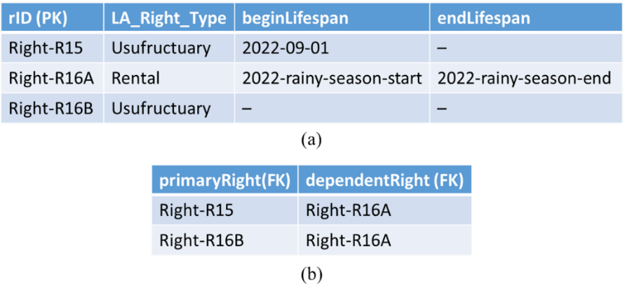

Figure 24. Rights can be annotated with (a) temporal constraints and (b) dependencies can enforce temporal dependencies between different rights.

The modelling strategies presented apply to formal rights but can also be applied to some non-statutory rights as demonstrated for a customary use right above. This realisation tells us that a country profile can be extended locally to accommodate different kinds of rights.

This brings us to the Modelling of the internal land relations within the customary areas. In this paper we will demonstrate only one kind of customary resource-use right, namely, water access rights.

In our scenario, tradition stipulates that members of the community cannot be excluded from accessing a water resource constructed at the home of a community member, provided 1) the use is for domestic subsistence purposes (i.e. drinking, cooking, sanitation), and 2) the user contributes in maintenance activities on the water resource. One approach to modelling these scenarios is illustrated Figure 24. In Figure 24 we see that Ramon has a *domestic water use right* and a *maintenance responsibility on* the water resource owned by Sergey, but both Sergey and Ramon have full water access rights on the Basic Administrative Unit BAU-R12 holds all the natural water resources on the community's lands.

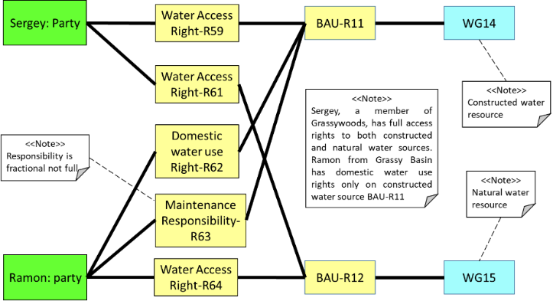

Figure 25. Water access scenario where water resources are modelled as Spatial Units.

This example demonstrates some of the challenges students may face in modelling complex land tenure relations. The instance diagram in Figure 25 gives the impression that the rights are independent of any other factors within the model itself. However, as explained above, the domestic Water Use Right-R62 is contingent on the Maintenance Responsibility R63. On the other hand, other water uses not shown in the diagram are restricted for party Ramon on Basic Administrative Unit BAU-R11. These rules cannot be captured in any static UML diagram as they involve a change in the state of individual or composite objects (constituted by a set of individual objects of the same or different classes). As alluded to at the onset, dynamic model diagrams, including Activity and State Machine diagrams, can be used in such complex scenarios.

1. CONCLUSIONS

LADM is flexible, high level model for implementation of information systems in the Land Administration domain. But while it is versatile and powerful in this context, our experience teaching how to apply LADM showed that learning it can be challenging for both novices and non-technical land professionals.

The new approach we have developed seeks to introduce the fundamental concepts of LADM by starting at a low level of abstraction. This approach provides greater flexibility to the didactic approach, thus making it easier to suit different learning outcomes. However, it is crucial to emphasise that although the level of technical detail that can be addressed is very high, the ultimate goal is still to teach the concepts of LADM.

Another important takeaway from our experience is that the adaptations teaching had to take during COVID times, especially regarding distance and hybrid education, kickstarted a redevelopment of teaching materials and rethinking one's approach to teaching strategies. In that respect, having a set of educational materials that are distributed as a file-based system, a server-client architecture, or a web-based viewer will certainly serve several teaching modalities that have come to stay.

In a natural way, concepts from land administration and database concepts are integrated and – understood. All introduced tools will be published under an open, permissible license to invite all actors in the community to use them.

WEBSITES

LADM documentation:

<https://wiki.tudelft.nl/bin/view/Research/ISO19152/>

Social Tenure Domain Model:

<https://stdm.gltn.net/>

PostGIS:

<http://postgis.net/>

PostgreSQL:

<http://www.postgresql.org/>

QGIS Geographic Information System:

<http://www.qgis.org>

Web map application with the datasets (exploratory uses only): <https://sigap.pt/lizmap/index.php/view/map/?repository=ladm&project=water_river_village_NO_BAU> - this is a *temporal link;* the final, link will be announced during the presentation

REFERENCES

Anderson, L., Krathwohl, D., Airasian, P., Cruikshank, K., Mayer, R. Pintrich, P., Raths, J., and Wittrock, M. (2001) A Taxonomy for Learning, Teaching, and Assessing: A Revision of Bloom's Taxonomy of Educational Objectives

<https://www.uky.edu/~rsand1/china2018/texts/Anderson-Krathwohl%20-%20A%20taxonomy%20for%20learning%20teaching%20and%20assessing.pdf>

Chipofya, M., Karamesouti, M., Schultz, C. and Schwering, A. (2020) Local Domain Models for Land Tenure Documentation and their Interpretation into the LADM. Land Use Policy, 99

<https://doi.org/10.1016/j.landusepol.2020.105005>

Chipofya, M.C., Jan, S. and Schwering, A. (2021) SmartSkeMa: Scalable Documentation for Community and Customary Land Tenure. Land, 10(7), 662

<https://doi.org/10.3390/land10070662>

ISO/TC211 (2012) Geographic information - Land administration domain model (LADM). First Edition 2012-12-01. Lysaker, Norway <https://www.iso.org/standard/51206.html>

Kalogianni, E., Janečka, K., Kalantari, M., Dimopoulou, E., Bydłosz, J., Radulović, A., Vučić, N., Sladić, D., Govedarica, M., Lemmen, C.H.J. and Van Oosterom, P.J.M. (2021) Methodology for the development of LADM country profiles. In: [Land Use Policy](https://www.sciencedirect.com/science/journal/02648377), [Volume 105](https://www.sciencedirect.com/science/journal/02648377/105/supp/C), June 2021 <https://doi.org/10.1016/j.landusepol.2021.105380>

Kara, A, Bennett, R., Lemmen, C. and Van Oosterom, P. (2022) Proceedings of the 10th International FIG workshop on the Land Administration Domain Model, Dubrovnik, Croatia. Federation of Surveyors (FIG). Copenhagen, Denmark

<https://doi.org/10.4233/uuid:446ad684-b9e0-48c2-81d9-85fc22537ddc>

Lemmen, C.H.J. (2010) The social tenure domain model: a pro-poor land tool. FIG publication No. 52. International Federation of Surveyors (FIG). Copenhagen, Denmark

<https://www.fig.net/resources/publications/figpub/pub52/figpub52.pdf>

Lemmen, C., Van Oosterom, P. and Bennett, R. (2015) The Land Administration Domain Model. Land Use Policy 2015, 49, 535–545 <https://doi.org/10.1016/j.landusepol.2015.01.014>

UN-Habitat (2008) Secure land rights for all. Nairobi, Kenya, 2008

<http://mirror.unhabitat.org/pmss/getElectronicVersion.aspx?nr=2488&alt=1>

Seidl, M., Scholz, M., Huemer, C. and Kappel, G. (2012) UML@Classroom: An Introduction to Object-Oriented Modeling. Springer Cham. <https://doi.org/10.1007/978-3-319-12742-2>

Venters, C., Lau, L., Griffiths, M., Holmes, V., Ward, R., Jay, C., Dibsdale, C. and Xu, J. (2014) The Blind Men and the Elephant: Towards an Empirical Evaluation Framework for Software Sustainability. Journal of Open Research Software, 2(1)

<https://openresearchsoftware.metajnl.com/articles/10.5334/jors.ao/>

BIOGRAPHICAL NOTES

Christiaan Lemmen is full Professor Land Information Modelling at the Faculty of Geo-Information Science and Earth Observation of the University of Twente in the Netherlands. His other main job is as Senior Geodetic Advisor at Kadaster International, the international branch of the Netherlands Cadastre, Land Registry and Mapping Agency.

Andre da Silva Mano is a Lecturer on geoinformatics at the Faculty ITC. Large experience in designing and implementing presential and online courses on GIS and Spatial Analysis using open tools. Has conducted workshops in India, Ethiopia, Spain, Portugal, Island of Saint Helena and for the Guyana Lands and Surveys Commission. He is an enthusiast of Open Source GIS Software.

Malumbo Chipofya is Assistant Professor of Land Informatics at the Faculty of GeoInformation Science and Earth Observation of the University of Twente. His research interests broadly cover modelling customary land tenure systems, applications of distributed and decentralised systems in Land Administration, and sketch based geodata creation and use in Land Information Systems.

CONTACTS

Christiaan Lemmen

University of Twente, Faculty of Geo-Information Science and Earth Observation/ITC

P.O. Box 217

7500 AE Enschede

THE NETHERLANDS

E-mail: [c.h.j.lemmen@utwente.nl](mailto:c.h.j.lemmen@utwente.nl)

Website: <https://people.utwente.nl/c.h.j.lemmen>

Andre da Silva Mano

University of Twente, Faculty of Geo-Information Science and Earth Observation/ITC

E-mail: [a.dasilvamano@utwente.nl](mailto:a.dasilvamano@utwente.nl)

Website: <https://people.utwente.nl/a.dasilvamano>

Malumbo Chipofya

University of Twente, Faculty of Geo-Information Science and Earth Observation/ITC

E-mail: [m.c.chipofya@utwente.nl](mailto:m.c.chipofya@utwente.nl)

Website: <https://people.utwente.nl/m.c.chipofya>